Meet the founders of Miluna, the bubble hotel of Toledo
2 April, 2019

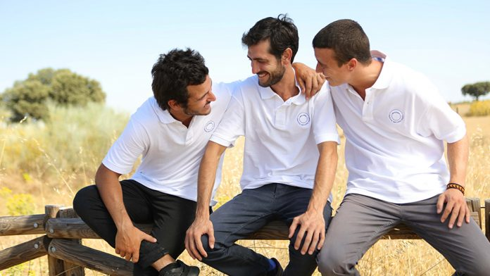

Less than a year ago, in September 2018, Spain added a unique proposal to its tourism offering. The idea came from three young Catalans who had the idea of turning a piece of land in Toledo into a glamping boutique resort.
Miluna Open Nature Rooms is a tourist complex, miles from any type of light pollution in the middle of nature with four 30m2 transparent bubble shaped rooms, offering its guests the unique experience of sleeping inside a moon with panoramic sky views and absolute privacy.
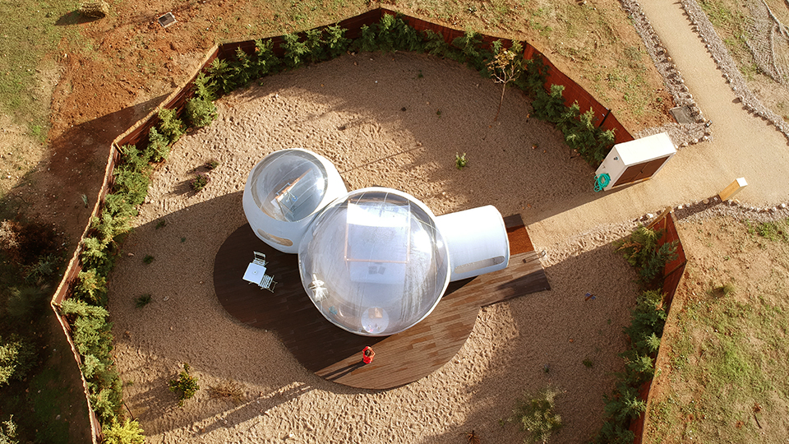
Miluna has enjoyed an occupancy rate of 95% since it first opened. Lookout Pro got the chance to sit down and chat with Jacobo de Llanza Rivero, Victor Messa Castany and Alejandro Bosch Bruna to discover a little more about this alternative bubble hotel accommodation.

How did the idea to start Miluna come about?
The 3 of us saw a hotel similar to Miluna when we went on a trip to France at the end of 2015. We were so impressed by what we saw, and although all of us had steady jobs, we decided to look into the possibility of doing something similar here in Spain We’d always wanted to start a different kind of business to create experiences and dreams.

Who is behind the project?
The 3 founding partners and 4 minority investors.

Why Toledo?
After carrying out an initial market study, we realised that this type of accommodation already existed in Catalonia, Navarra and Galicia We thought being close to Toledo, one of the most touristic cities in Spain, which is also close to Madrid with 8 million inhabitants just 100km away, could be the perfect strategic place to develop our business.

How many Moons are there?
At the moment we only have 4 Moons, but the idea is to have 8 by the end of 2019 and 12 in 2020.

You’ve been open for less than a year now. What have the results and the acceptance been like?
In terms of results, we could never have imagined a scenario like this. We have to be realistic, we’ve just launched the project, and we only have 4 rooms, but we’ve exceeded our expectations with an occupancy rate of 95% since we first opened in September 2018.
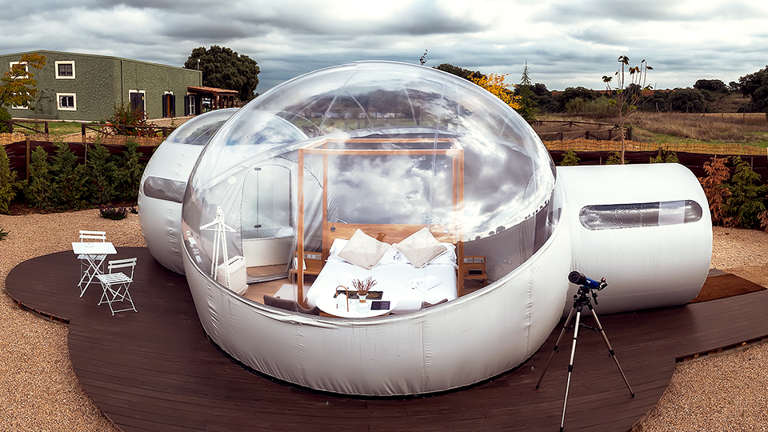
We’re delighted with the occupancy rate and the fact that the business model is working, but to be honest, what gives us the greatest happiness is the satisfaction of our clients. Our best remuneration is the comments our clients leave online and what they say to their friends and family after staying with us.
The people in Hormigos have really welcomed us with open arms. We’re delighted with how the people and the town council have helped us and made us feel at home.

Will we see more Moons in Spain?
Our idea is to replicate the concept in other places, but it’s still early days. The first thing we want to do is to consolidate our position with this first hotel, and then we’ll look at what we should do and how to do it.

What type of guest is Miluna intended for?
The type of guest we’re targeting is quite varied. Miluna can attract the attention of:
- People living in cities who want to escape from their everyday life, even if it’s just for a day to escape from stress and their daily routine.
- People looking to enjoy a different, original and unique experience, and add experiences to their lives.
- People who like the countryside and nature.
- People who want to give their partner, family member or friend a surprise.

What can guests expect when staying at Miluna?
We feel clients want them to experience something totally different from their everyday lives, and that’s what we want to offer them.
Most people come here with their partners, and very often one of them has no idea where they’re going, so they’re expecting to be surprised and make their partner happy. They want something quiet and romantic.

Is Miluna an answer to the demand for accommodation-experiences from millennial clients?
Definitely. The “Glamping” concept started in the United States a few years back. This is the sector we’re in, and it’s on the up and up.

Miluna is undoubtedly an “instagrammable” spot. Have you had any visits from Instagrammers/bloggers/influencers/celebrities?
It’s a unique, special place with a lot of charm. And as it’s new, it’s been given the thumbs up on social networks and has had an impact, so it’s definitely “instagrammable”. Instagrammers, bloggers and the media have come to visit us. We’re happy in this regard.

What’s the average age of those who have stayed at Miluna to sate?
The average age is around 35.

What have your guests highlighted most after their experience at Miluna?
Many of them come to enjoy an undiscovered experience. Many of them are worried about the heating or air-conditioning, others about privacy and others about what they may find.
All these doubts disappear once they’ve had the Miluna experience and their stay with us beats the expectations they had after seeing photos and reading comments online.
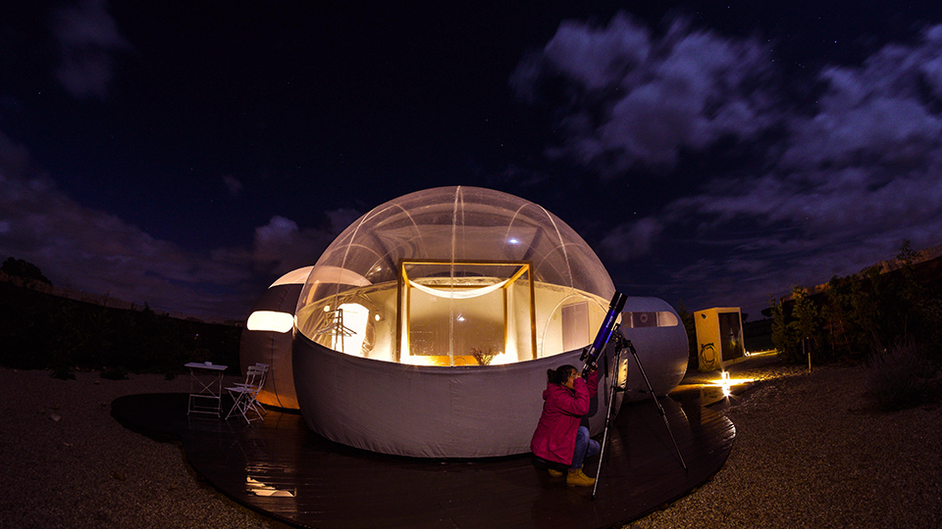
They feel right at home, and the personalised, friendly treatment makes them feel very comfortable staying with us. Based on the comments on social media (Instagram, Facebook, TripAdvisor, etc.), they leave delighted with the experience, and many of them talk about coming back.

